ART 100 **Art in Culture** | Prof. Heidi Leitzke

**Art History Timeline Assignment**

Step 1. Watch video on How to Do Visual Analysis <https://www.khanacademy.org/humanities/ap-art-history/introduction-ap-arthistory/v/visual-analysis>

Step 2. Visit Metropolitan Museum of Art Timeline

<https://www.metmuseum.org/toah/works/>

Step 3. Select an artwork from the timeline. Pick something that you are curious about or interested to learn more about. You will use this artwork to complete this assignment. You may type your written answers directly into the text field, or you may type into a Word.doc and then copy/paste at the end. In addition to the text submission, you will need to submit a .jpeg image of your drawing.

**DESCRIBE: fill in the artwork details**

Artist:

Title:

Date:

Medium:

Dimensions:

Location, where in the world was this art made? Or Where is the art from?:

**Link: copy and paste a link from the exact item you are looking at in the Heilbrunn Timeline of Art History.**

**ANALYZE: answer these questions about your artwork**

What was your first reaction to this artwork? Or in other works Why did you pick this artwork? Why do you think you had that reaction?

Make a drawing or diagrammatic sketch of your work of art trying to understand the main compositional forces. Diagram, draw, make notes on the following:

EMPHASIS

* Where is the focal point?
* How did this artist use balance or imbalance?

MOVEMENT

* How does your eye move through the artwork? What choices did the artist make to make that happen?
* How did this artist use line or implied line?

COLOR

* Describe the colors in the image? What do the colors remind you of? What might the colors represent?

Here is a sample of what the diagrammatic drawing might look like in relationship to the original painting.

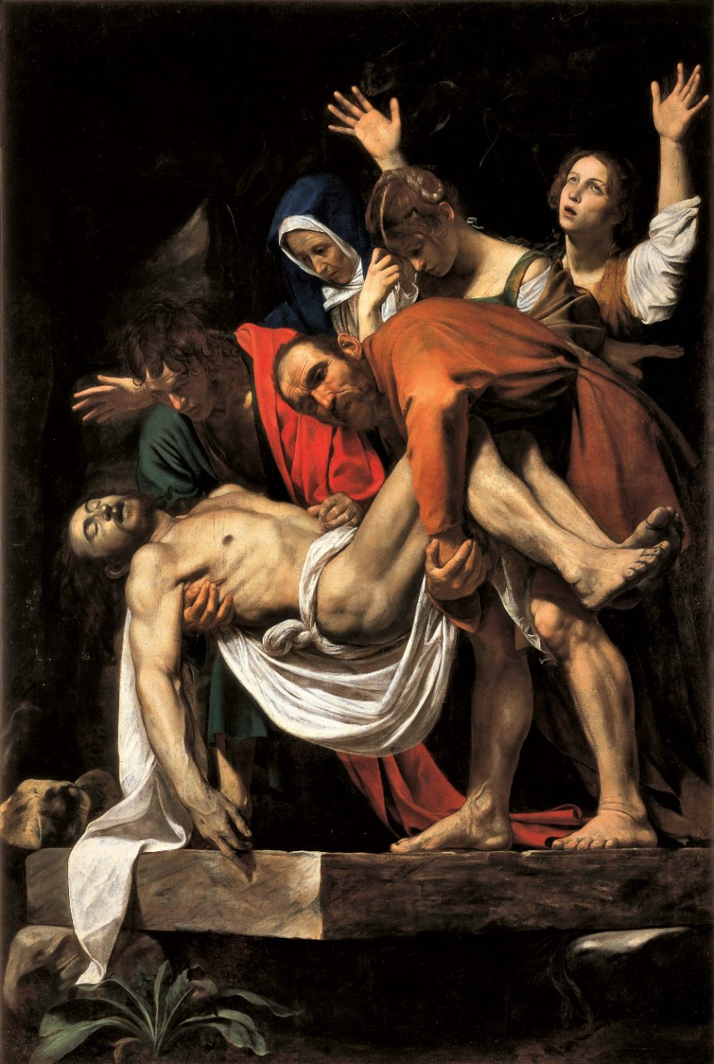 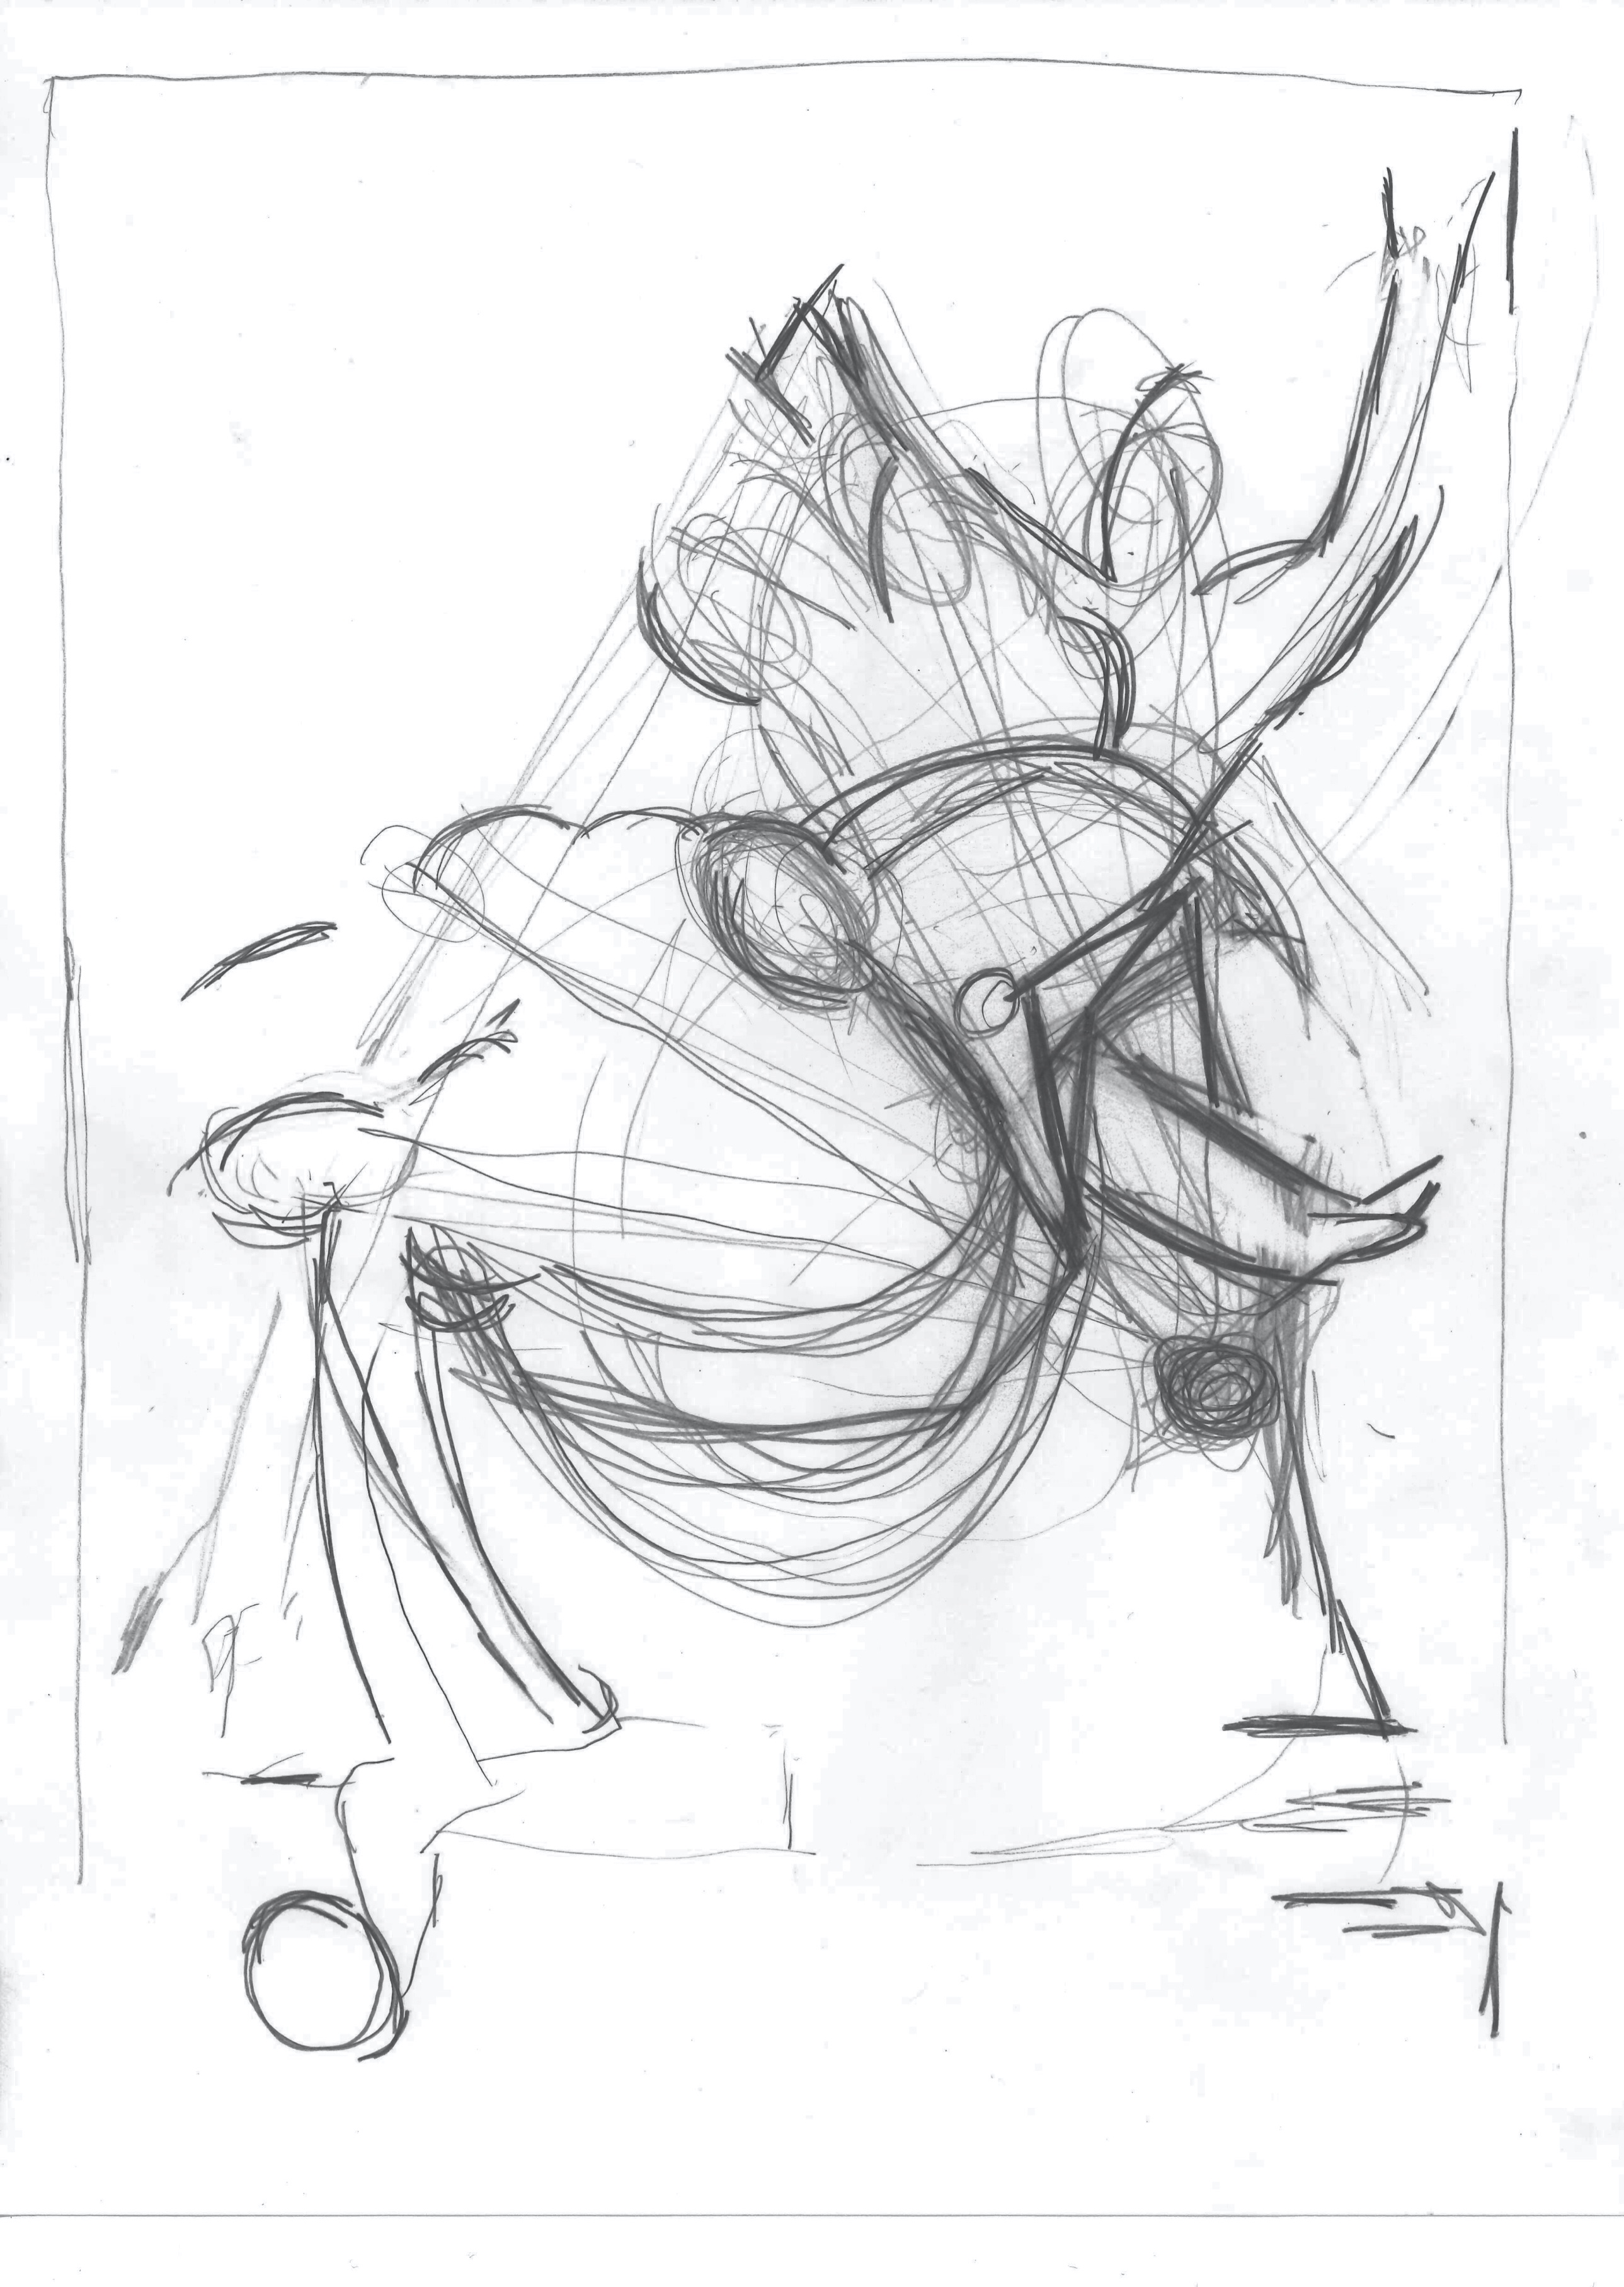

**INTERPRET: answer these questions about your artwork**

What do you think is the meaning or message (Content) of this artwork?

How does the title contribute to your understanding of this meaning?

Can you find any symbols or objects that may have symbolic meaning in this artwork? Describe the symbolism.

How your opinion about the artwork changed, the longer you have looked at it?

**SUBMIT** your typed answers with a jpeg image of your sketch to the Visual Analysis Timeline Project on D2L.